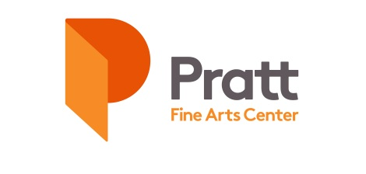

TUITION ASSISTANCE PROGRAM
Pratt’s mission is to make art accessible to everyone. Pratt raises funds to subsidize the cost of participation and maintain the lowest possible fees for its programs. And yet, there are many who still cannot afford to participate. The Tuition Assistance Program (TAP) aims to provide a deeper subsidy to those who would not otherwise be able to participate due to financial limitations.
Tuition Assistance is applied as a 75% discount on the class fee for a class of the applicant’s choice. TAP does not cover supply fees. Applicants are responsible to pay the remaining balance of the class fee as well as any supply fee associated with their chosen class.
ELIGIBILITY
Those whose household income falls at or below 300% of the Federal Poverty Guidelines (shown below) are eligible for Tuition Assistance. If your household income is EQUAL TO or LESS than the amount in the following chart, you are eligible for Tuition Assistance at Pratt Fine Arts Center:
DEFINITIONS:

*Household Size: this number includes the applicant, any other individuals who share financial responsibility for the household, and all dependents

**Household Income: the combined gross income generated each year by all household members, as reported on IRS annual income tax forms

Household Size* | Household Income**
1 | $38,640
2 | $52,260
3 | $65,880
4 | $79,500
5 | $93,120
6 | $106,740
7 | $120,360
8 | $133,980

EXCEPTIONS
- Only one TAP student is allowed per class, on a first-come, first serve basis.
- TAP students do not count towards the minimum enrollment requirement to run a class. If a TAP student is enrolled in a class that is canceled, TAP students are encouraged to reapply.
- TAP is not available for specialty programs such as Study Abroad, Master Artist, or Summer Camp Aftercare programs.

APPLICATION CYCLES
Pratt's Tuition Assistance Program is now accepting applications on a rolling basis.

HOW TO APPLY
- Choose a preferred class and a back-up choice in case that preferred class is not available.
- Complete the TAP application; contact info@pratt.org if you have any questions.
- Submit your completed application by email to info@pratt.org.

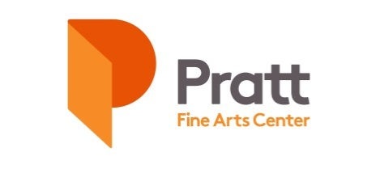

TUITION ASSISTANCE PROGRAM (TAP) APPLICATION

- Applicant Information
Name: ______________________________________________________________ Age: ______________
Address: _______________________________________________

City: ______ State: Zip: __________

Email Address: _______ ______ Phone: _ ____

2. What is your Household Size*? __________ *see eligibility chart and definitions

3. What is your Total Household Income (Annual Gross)*? $____________ *see eligibility chart and definitions

PLEASE NOTE: Pratt reserves the right to request IRS documentation for income verification.

4. Have you ever received Tuition Assistance from Pratt Fine Arts Center? Yes ____ No ____

If yes, please list the date and class: ______________________________________________________________

5. In which class would you like to enroll?
TITLE | INSTRUCTOR CLASS NO.|CLASS DATES CLASS FEE | SUPPLY FEE
___________________

6. If your preferred class is not available, in which alternate class would you like to enroll?
TITLE | INSTRUCTOR CLASS NO.|CLASS DATES CLASS FEE | SUPPLY FEE

___________________
7. Signature of Applicant (or Guardian if applicant is under 18):

Signed ___ Printed __ ____________________________ Date ____________

Submission of this signed registration form constitutes applicants voluntary submission of financial information and all terms and conditions in
the registration policies including the conditions of Pratt’s refund policy and the waiver.

RESEARCH & DEMOGRAPHICS (Responses are Optional & Support Pratt’s DEI Initiatives - https://www.pratt.org/commitment-equity.php)

In terms of race, ethnicity, and gender, how do you self-identify?
Race:
- American Indian or Alaska Native
- Asian
- Black or African American
- Native Hawaiian or Other Pacific Islander
- White
- ___________________________
Ethnicity:
- Hispanic or Latino
- Non-Hispanic or Latino
- __________________

Gender:
- Male
- Female
- Non-Binary
- ___________

Have you taken classes at Pratt before? Yes ____ No ____ If yes, please list: _______________________________

How did you learn about Pratt Fine Arts Center’s Tuition Assistance Program? ________________________________

